Phone: 0137560817 Email: ashrafsedc@gmail.com
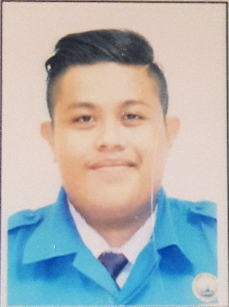
ALIFF ASHRAF BIN AZMI
DIPLOMA IN COMPUTER ENGINEERING AND NETWORKING
- Seeking a challenging career with a progressive organization that provides an opportunity to capitalize my technical skills and abilities in the field of information technology (IT) and networking.

PERSONAL SKILLS
EDUCATION
- NETWORK TROUBLESHOOTING
- MICROSOFT OFFICE (MS WORD,EXCEL,POWERPOINT,ETC)
- PROGRAMMING (C++,PHP, MySQL)
- VARIOUS OPERATING SYSTEM (LINUX, UNIX, WINDOW SERVER, Ubuntu)
- PACKET TRACER

TECHNICAL SKILLS
CAREER OBJECTIVE

Address
No 5,jalan siantan 4,Taman kemas
81200 ,Johor Bahru Johor

Diploma of Computer engineering and Networking
University of Kuala Lumpur
Wilayah Persekutuan Kuala Lumpur,Malaysia CGPA:3.0
Major : Network engineering
Minor : Computer

Sijil Pelajaran Malaysia
Sekolah Menengah Kebangsaan Taman Jelutong
Kulim,Kedah

- Join networking completion (net rider)
- Leader of final year project group
- Complete CCNA 1 to CCNA 4 certificate

ACHIEVEMENTS/
RESPONSIBILITIES

- GOOD COMMAND OF ENGLISH, MALAY AND MANDARIN (BOTH SPOKEN AND WRITTEN)
- Basic Mandrin
- HIGHLY ORGANIZED AND EFFICIENT
- ABILITY TO WORK INDEPENDENTLY OR AS PART OF A TEAM
- PROVEN LEADERSHIP SKILLS AND ABILITY TO MOTIVATE

